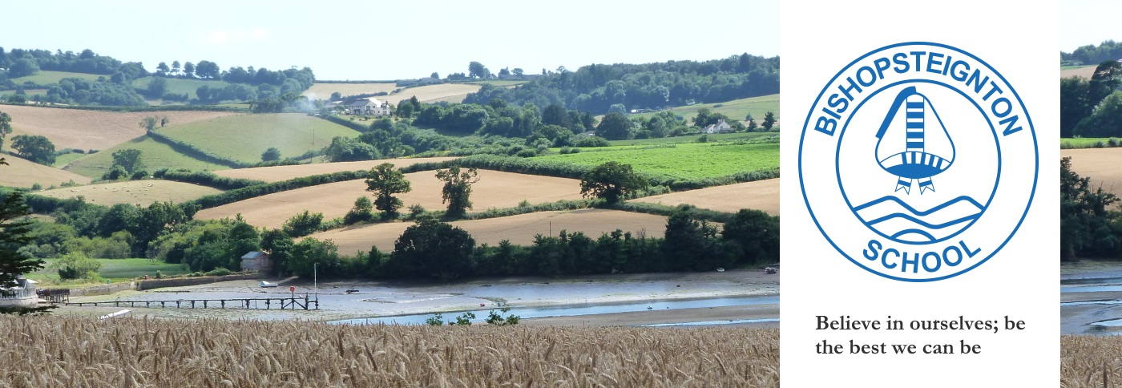
March 2023
As another busy term comes to an end and our thoughts turn to warmer days, Easter egg hunting and just how many weeds have suddenly appeared in the garden, we would like to share with you some of the work that various members of the Governing Board have been doing behind the scenes this term.
Firstly, we are pleased to share with you some information about Faye Robertson, one of our Parent Governors.
Faye Robertson
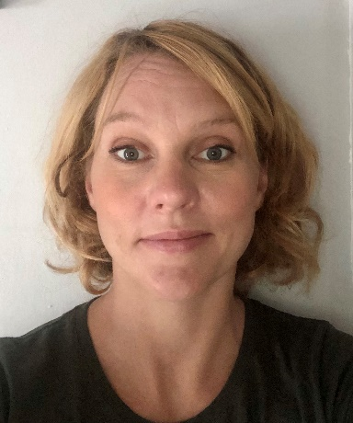
Faye has been a parent governor since 2020 when her daughter was in the pre-school. Her background is as a secondary maths teacher and later as a Head of Maths. She now consults for schools, with specialisms in maths, assessment and educational psychology. She also trains new and existing teachers across the secondary and primary levels. She is completing a Masters in Psychology with a focus on children with additional needs and has been part of several published research projects including pre-teaching intervention strategies and language acquisition in deaf and hard of hearing infants. Faye is responsible for the Maths and SEN strands as a governor.
If you want to find out more about any of the other Governors please visit the school website, “Our Community | Governors” page for more details. For the first time in a few years, we are now a full complement of twelve governors which is great news as many schools have long standing vacancies and struggle to recruit new governors.
Governor Activity
This term we were sorry to learn that Steve Morgan had decided to step down from the Governing Board and we would like to thank him wholeheartedly for all his hard work and support on the Resources Committee and his dedication to the role of Communications Governor. We have now welcomed Nick Long as a Parent Governor to the Governing Board.
Our School Governing Board helps to provide the strategic direction for the school and its main role is to support and challenge the school leadership team with the aim of improving outcomes for pupils. It can be a challenging role at times, but of course it is also hugely rewarding. Many governors attend online or in person training in order to fulfil their responsibilities. We give up our time freely to attend meetings and make focused visits to the school, so we can be knowledgeable about how the school is performing and can help to support whole school improvement plans.
Focus on Governor Visits
Several visits have taken place this term by individual governors. Pauline Morley was invited to see how senior leaders in collaboration with class teachers review the children’s progress and then agree targeted interventions or areas of maths and literacy learning that might need greater focus.
Paul Zaleski had a very positive meeting with F.O.B.S and we would like to extend our appreciation to all those involved in helping to raise funds for the both the school and Preschool.
Sonya Lamoon visited Preschool and was very impressed with the setting; it is a well organised space that has a lovely, calming, nurturing atmosphere. All the children are expertly guided in their play and are happy and settled, mainly thanks to the expertise of the staff who know the children very well and can respond to their needs appropriately.
Faye Robertson met with Jodie Jennings to discuss her role as Maths Lead and how White Rose Maths is being implemented and embedded into the maths curriculum. Jodie Jennings and the teaching staff are working very hard to ensure the scheme meets the needs of the children and is strengthening their maths skills – so thank you to the whole team for this!
Phonics and Reading Monitoring Visit
In every school across the country children will be following a systematic phonics scheme in Reception and Year 1 with the aim that they will be fluent readers by the time they reach Year 3. In Year 1 children are expected to meet or exceed the expected standard in the Year 1 phonics screening check. Our school has devised its own scheme (Bishop Phonics) and a school improvement officer from Devon County Council was recently invited to carry out a monitoring visit to evaluate the phonics and early reading curriculum. We are delighted to say that her visit report was very positive and clearly shows how hard the teaching staff are working to ensure children have the best start in developing their reading skills – here is a snapshot of some of her findings:
Phonics lessons are consistently delivered across EYFS and Y1, in line with school's expectations Teachers motivate children and as a result there is high engagement of pupils There is clear evidence of the sequence of learning within a lesson and over time.
If you would like any further information about the teaching of reading in school then please take a look on the school website for more details.
FOBS – Friends of Bishopsteignton School
Another big thank you to FOBS who have planned some great fundraising events this term. Last year just over £7000 was raised and these funds greatly enhance the school curriculum in all sorts of ways, from paying for school trips, to funding forest school sessions and providing resources for classrooms. This year, as well as funding more forest school sessions, each class will have a budget of their own to make decisions about resources which will best suit their needs and some additional funding will support some upgrading of library resources. FOBS is run entirely by parent/carer volunteers and without their support many of the events wouldn’t be able to go ahead, so if you can offer a couple of hours a year to help out at an event, please get in touch with a member of FOBS or contact the School Office. They will be very pleased to have your support! As always, the Governing Board and whole school are very grateful for their continued support and we hope the whole community can support them in whatever way they can through the upcoming Summer term.
With our very best wishes for a lovely Easter break with friends and family,
Bishopsteignton Governing Board
Governor contacts: Should you wish to contact the governors please email our Chair of governors chair@bishopschool.co.uk or Geoff Jones clerk1@bishopschool.co.uk
SCHOOL GOVERNORS
CHAIR OF GOVERNORS: Dave Boobyer, Co-opted
LOCAL AUTHORITY GOVERNOR: Graham Hooker
CO-OPTED GOVERNORS: David Lamboll | James Kilby | Pauline Morley | Sonya Lamoon
PARENT GOVERNORS: Paul Zaleski | | Faye Robertson | Chris Merritt | Nick Long
STAFF: Emma Leballeur (Staff Governor) Dave Killoran (Headteacher) | Geoff Jones (Clerk)

